**AWS Data Analytics Design Patterns**

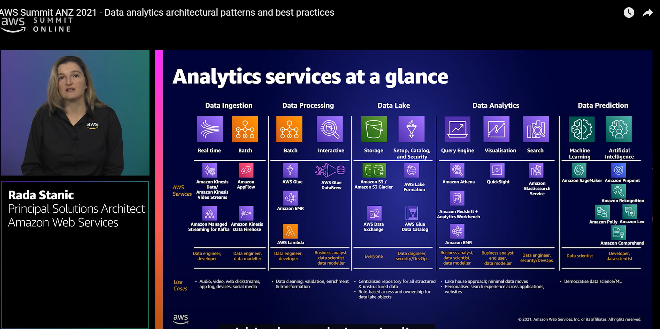

**Data Lake House Approach - pattern 1**

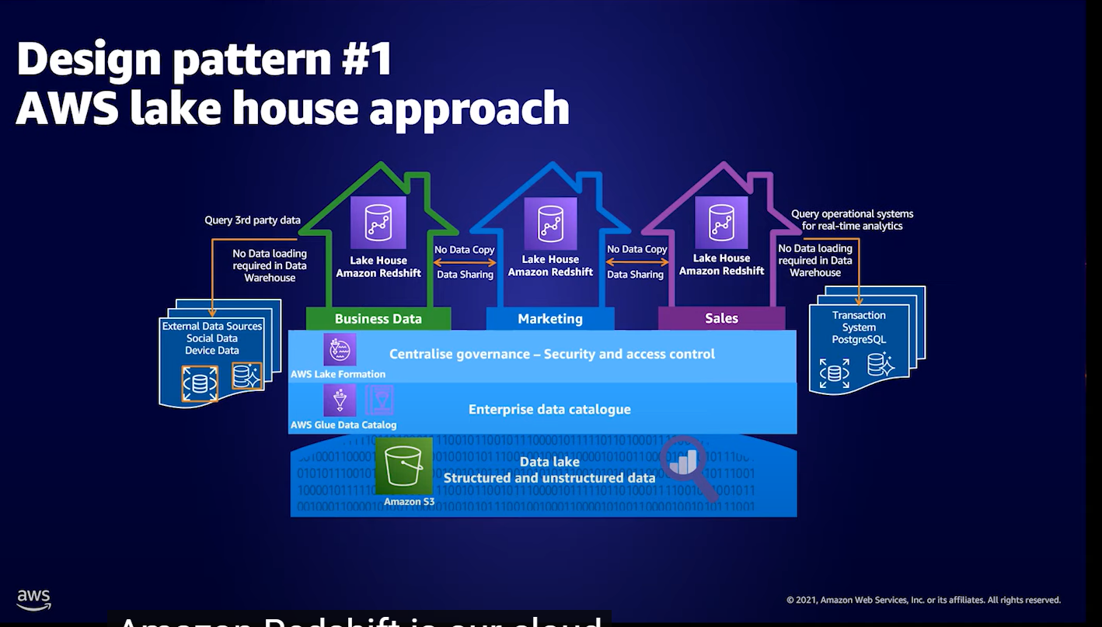

**AdHoc analysis using Athena - pattern 2**

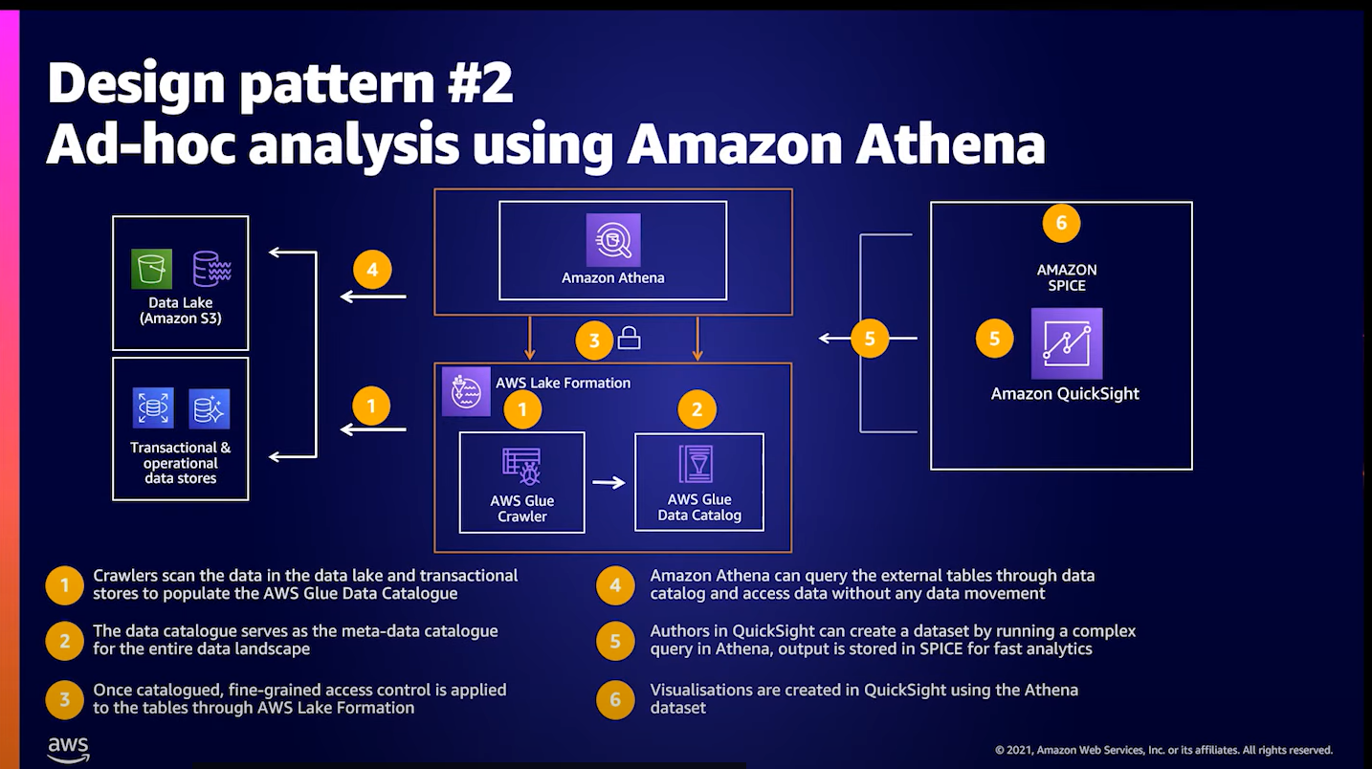

**AdHoc analysis using Athena and Redshift - Pattern 3**

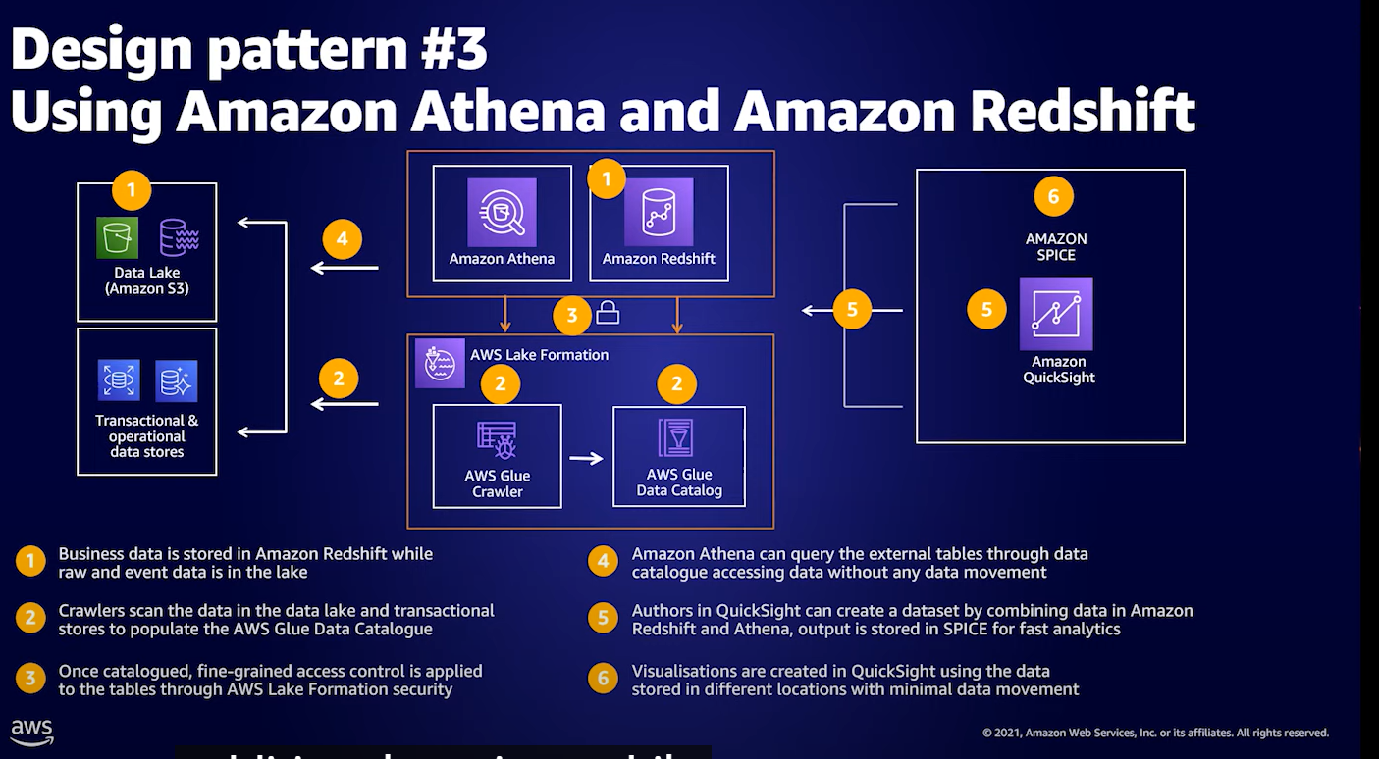

**Persona Centric Data analytics - pattern 4**

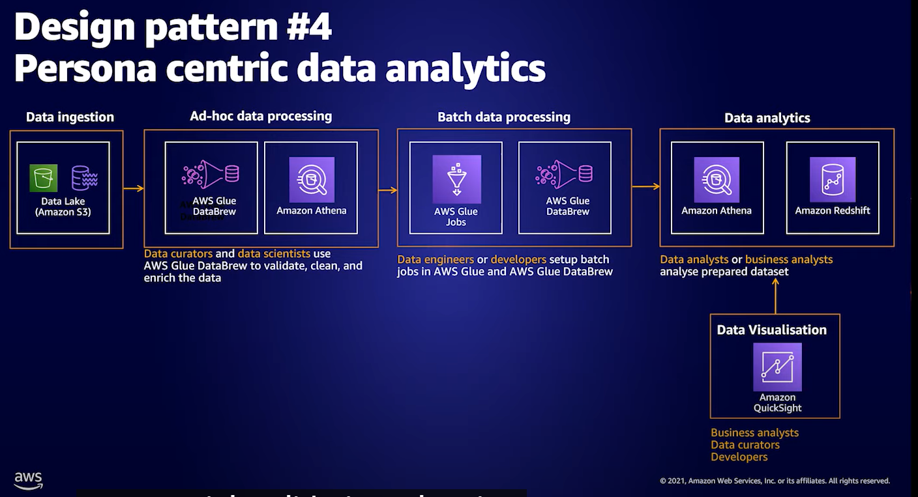

**Data Orchstration and ETL - pattern 5**

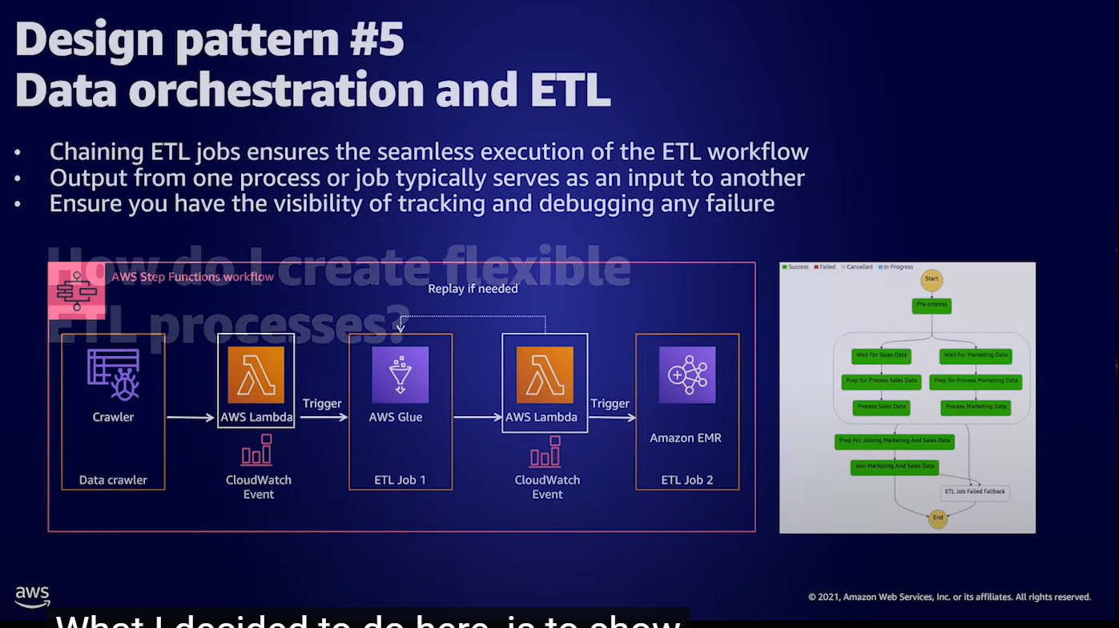

**Loading Data Warehouse - pattern 6**

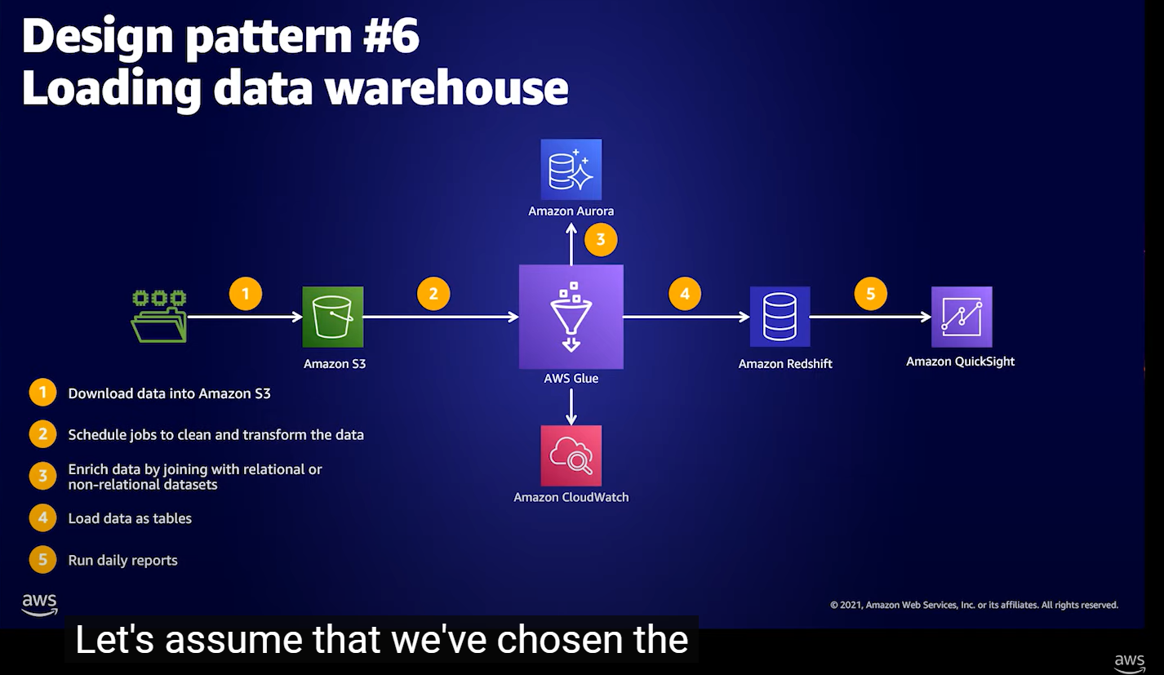

**Data Preparation for Ai/ML - pattern 7**

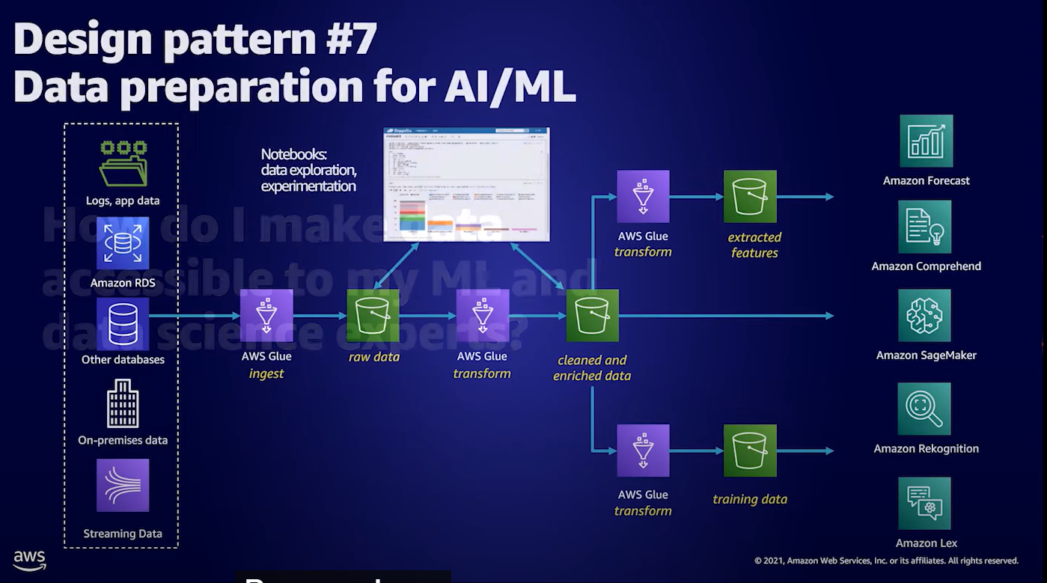

**Batch Processing - pattern 8**

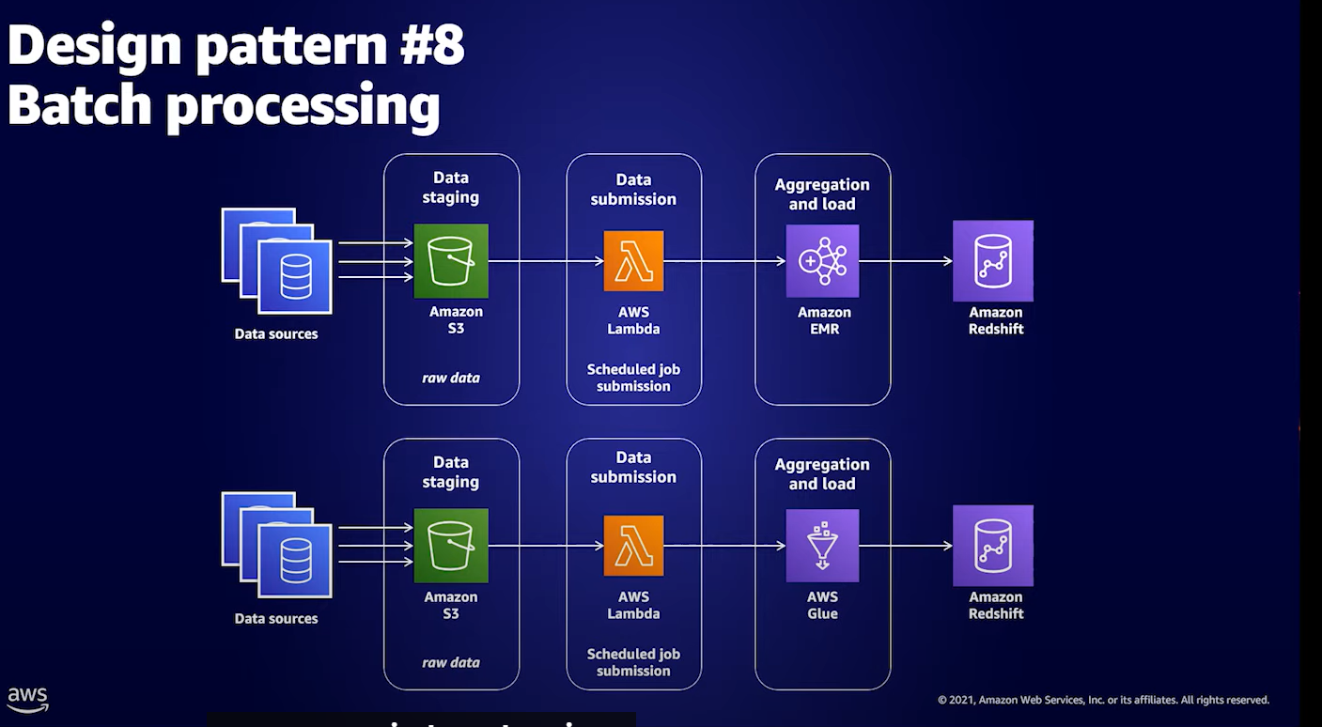

**Stream Processing - pattern 9**

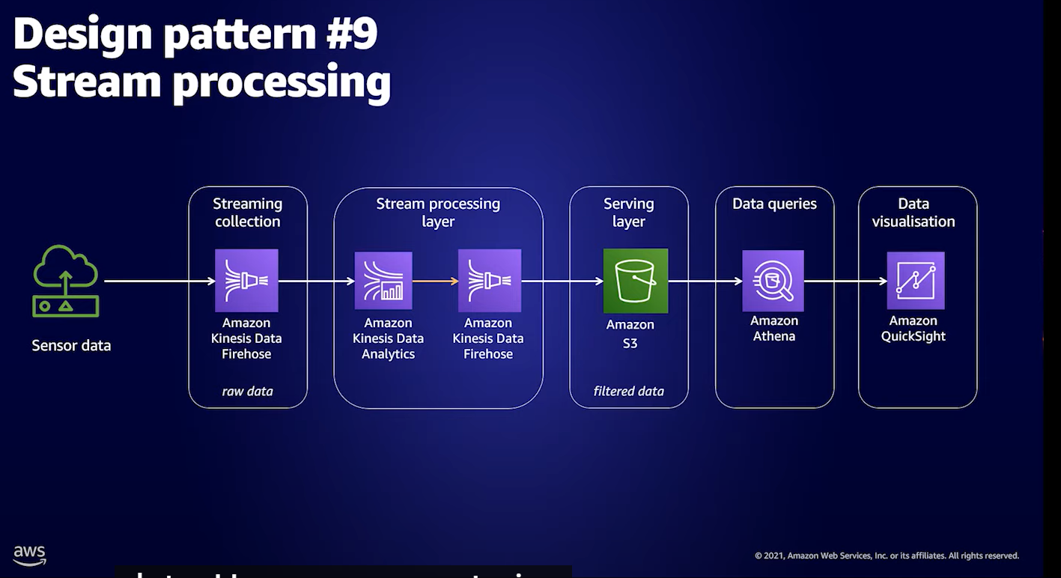

**Batch & Stream Processing - pattern 10**

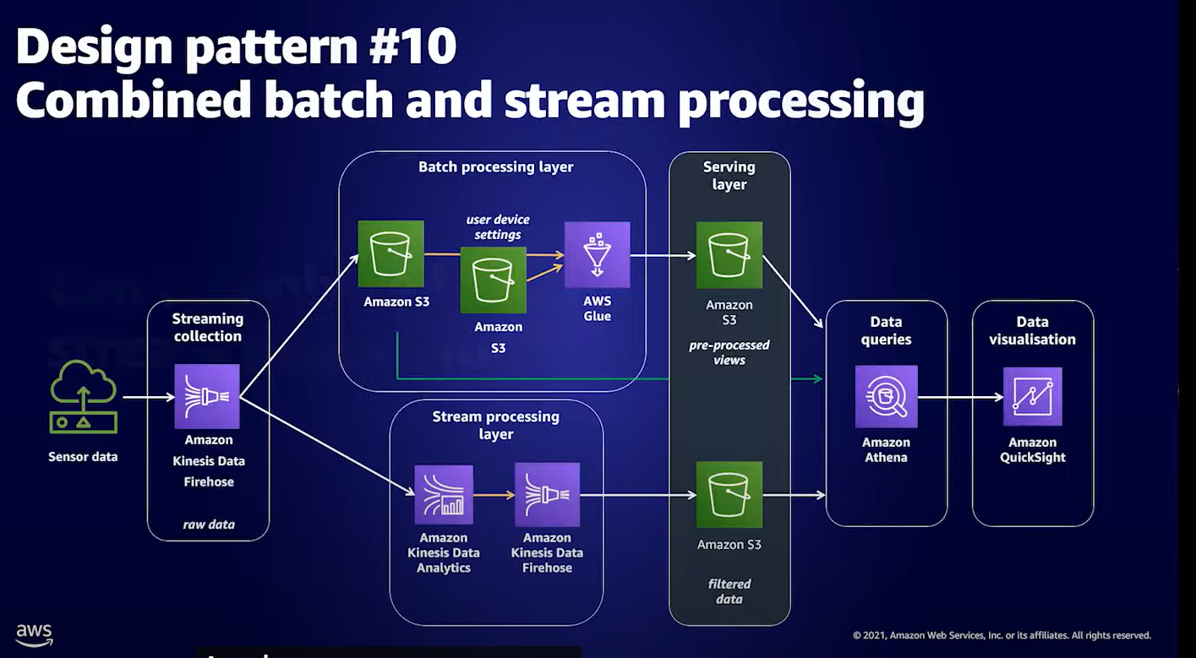

**AWS Tools**

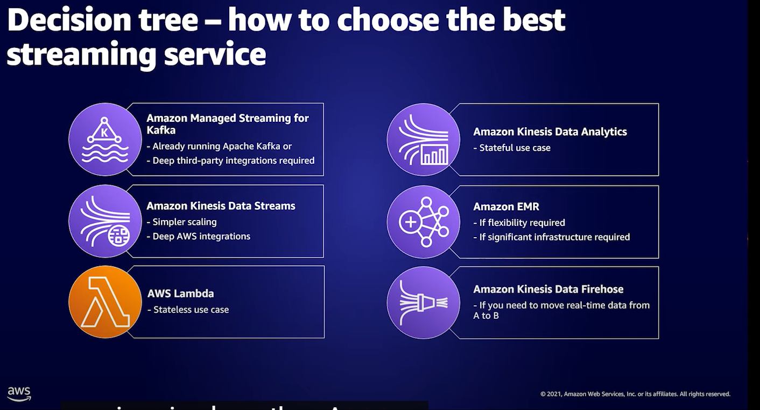

**Data Lens**

